Planning dep

# Note Planning

## Authentication by Key Trust

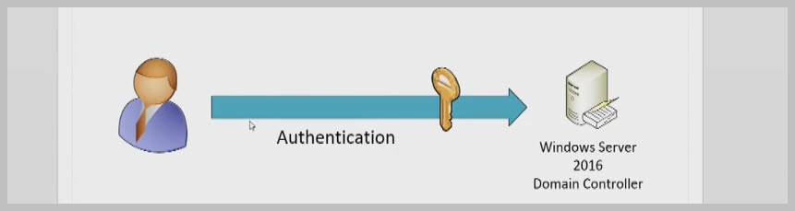

## Certificate Trust Model

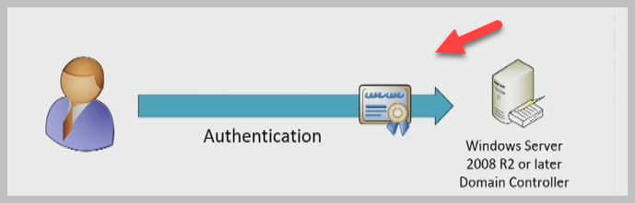

## Example of Infrastructure (on premise)

